# Setup AN Quick Start

---Kenny

Setup AN

1. Install JDK

<http://www.oracle.com/technetwork/java/javase/downloads/jdk7-downloads-1880260.html>

1. Setup Environment variables

|  |  |
| --- | --- |
| CLASSPATH | .;%JAVA_HOME%\lib;%JAVA_HOME%\lib\tools.jar |
| Path | ;%JAVA_HOME%\bin |
| JAVA_HOME | *your JDK root folder |

1. Install eclipse

<http://www.eclipse.org/downloads/>

1. Install

Copy \\WL00070162\Shared\gradle-0.9-rc-1 to C:\gradle-0.9-rc-1

1. Install SVN
2. DownLoad Project code & update it

Copy \\WL00070162\ActiveNetQ12012-ACM

1. Config for SQL Server
2. SQL Server Configuration Manager

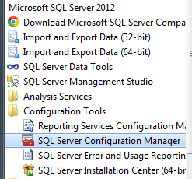

1. Enable all TCP\IP settings



1. Create sql admin users “recware” pw: “safari”
2. Restart SQL Server
3. Restore 3 DBs (ActivenetDB, ActiveNetLogs, ActiveNetSites) & Upgrade DB
4. The bak files are in \\WL00070162\bak2\
5. Upgrade DB [SourceCodeFolder]\DBSchema\AnUpsizer.exe  
   *Please ignore the error in result  
   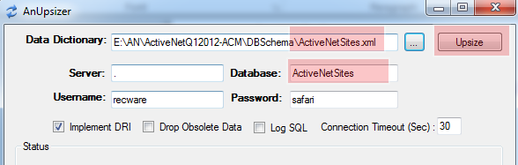

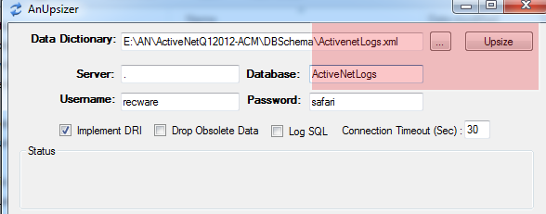

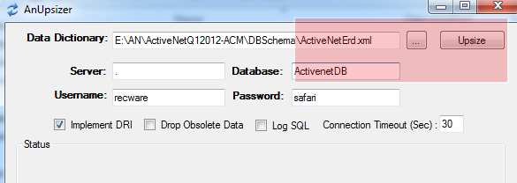

1. Config [SourceCodeFolder]\sdi.ini & make sure port 8080 is not used

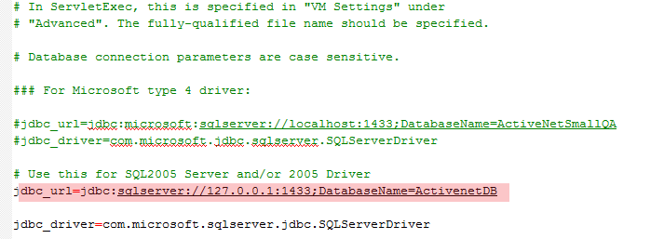

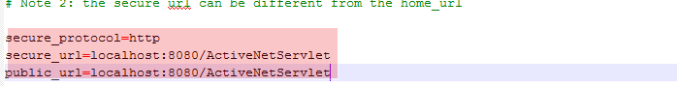

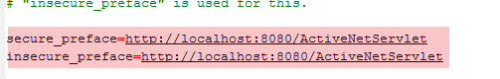

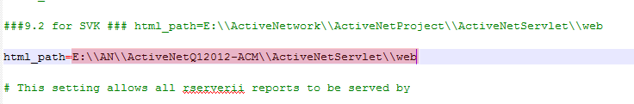

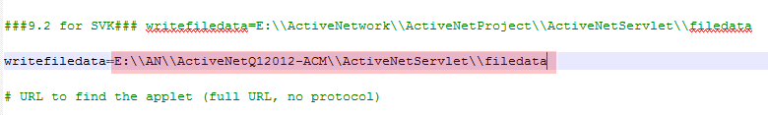

1. Config [SourceCodeFolder]\gradle-app.setting

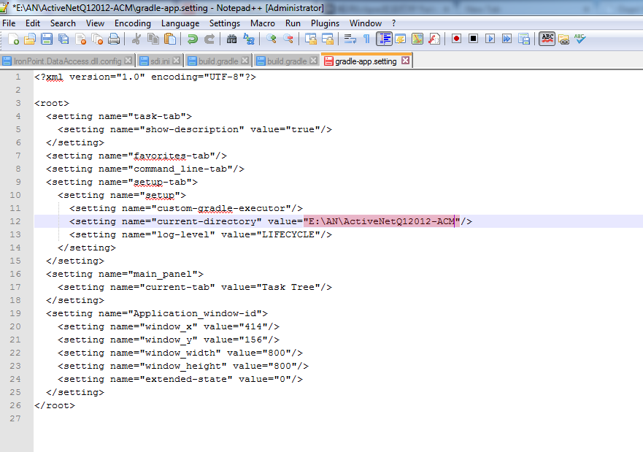

1. Run [SourceCodeFolder]\debug.bat
2. Access AN via <http://localhost:8080/ActiveNetServlet/adminLogin.sdi>

User: recware pw: safari

Setup CUI

1. Create DB   
   run script \ACM\ACMRoot\DatabaseScripts\IronPoint.Install.SQL2012.sql

Or IronPoint.Install.sql

1. Config Connection string \ACM\ACMRoot\bin\IronPoint.DataAccess.dll.config



1. Create new IIS Application

*Please notice the security setting

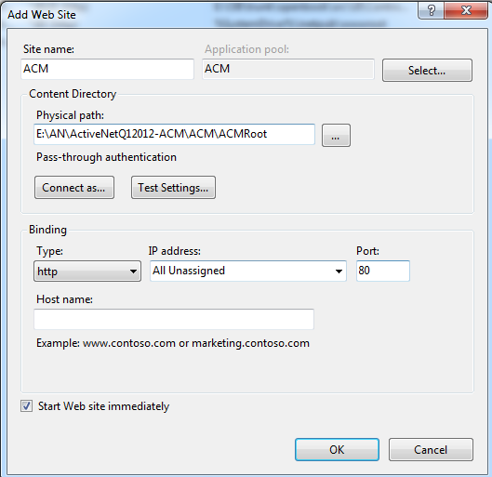

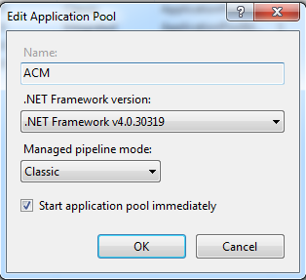

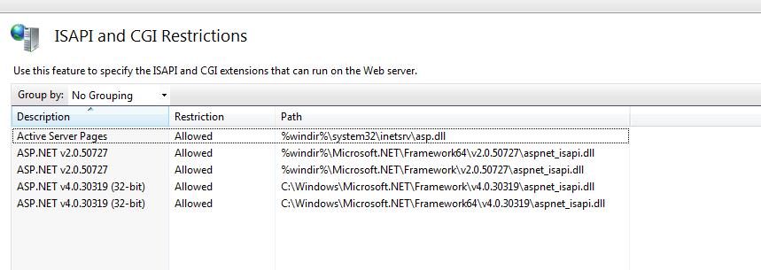

1. Access CUI via <http://localhost/site3.aspx>

You should see a page like this

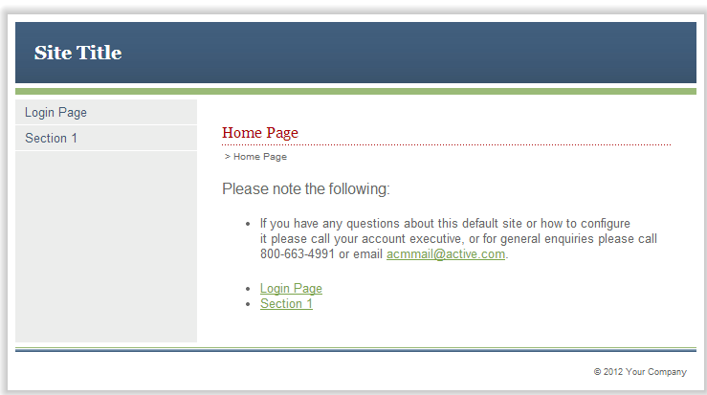

1. Run \ACM\Deployer\Deployer.exe

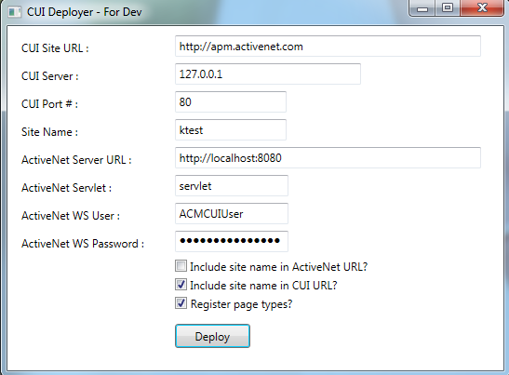

1. Config for CUI & restart iis

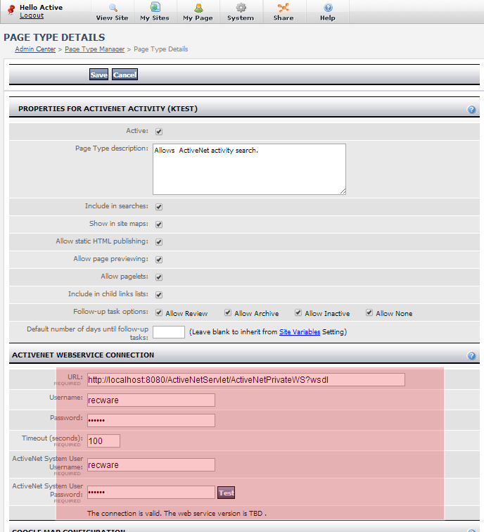



1. Config on AN

